Standard Area Measurements User Guide
December 2021
Edition No.: | 1
ONS Geography
Office for National Statistics

A National Statistics publication  National Statistics are produced to high professional standards set out in the Code of Practice for Official Statistics. They are produced free from political influence.  About us  The Office for National Statistics  The Office for National Statistics (ONS) is the executive office of the UK Statistics Authority, a non-ministerial department which reports directly to Parliament. ONS is the UK government’s single largest statistical producer. It compiles information about the UK’s society and economy and provides the evidence-base for policy and decision-making, the allocation of resources, and public accountability. The Director-General of ONS reports directly to the National Statistician who is the Authority's Chief Executive and the Head of the Government Statistical Service.  The Government Statistical Service  The Government Statistical Service (GSS) is a network of professional statisticians and their staff operating both within the Office for National Statistics and across more than 30 other government departments and agencies.  Contacts  This publication  For information about the content of this publication, contact ONS Geography  Tel: +44 (0) 1329 444971  Email: ons.geography@ons.gov.uk  Other customer enquiries  ONS Customer Contact Centre  Tel: 0845 601 3034  International: +44 (0)845 601 3034  Minicom: 01633 815044  Email: info@statistics.gov.uk  Fax: 01633 652747  Post: Room 1.101, Government Buildings,  Cardiff Road, Newport, South Wales NP10 8XG  https://www.ons.gov.uk  Media enquiries  Tel: 0845 604 1858  Email: press.office@ons.gov.uk |  | Copyright and reproduction  © Crown copyright 2022  You may re-use this information (not including logos) free of charge in any format or medium, under the terms of the Open Government Licence.  To view this licence, go to: https://www.nationalarchives.gov.uk/doc/open-government-licence/version/3/  or write to the Information Policy Team, The National Archives, Kew, London TW9 4DU  email: psi@nationalarchives.gov.uk.

Contents

A National Statistics publication 2
About us 2
Contacts 2
Copyright and reproduction 2
Introduction 4
Types of Measurements 5
Total Extent 5
Area to Mean High Water 5
Area of Inland Water 6
Area to Mean High Water Excluding Inland Water (Land Count) 6
Note on “extremely small” Output Area 6
Tolerance 10
Accuracy: Measurements for Great Britain 10
Comparisons with Previous Area Measurements 10
Currency of the Area Measurements 11
Guidance on the Use of Measurements for Statistical Purposes 11
Compiling Population Density Measurements 11
Other Uses of Measurements 11
Specific Measurements 11
Conditions of Use 12

Introduction
National Statistics has identified a need for a consistent approach to the production of definitive surface area measurements for use in UK statistical outputs and to meet the European Commission’s requirements for standardised area measurements (SAM) from member states.
The options for SAM measurements for use in UK statistical outputs are varied and no single type of measurement meets all requirements. Three key measurements are available: total extent, area to mean high water and inland water. A fourth (commonly used) measurement, land area, has been derived from these.
The following SAM measurements are produced:
- SAM measurements for all administrative areas in the United Kingdom are derived from aggregated ward level SAM measurements, yearly.
- SAM measurements for all electoral areas in Great Britain are derived from aggregated Westminster Parliamentary Constituency level SAM measurements, yearly.
- SAM measurements for all NHS health areas in England are derived from aggregated Clinical Commissioning Groups level SAM measurements, yearly.
- SAM measurements for all Lower Layer Super Output Areas (LSOA) and Middle Layer Super Output Areas (MSOA) in England and Wales are derived from aggregated Output Area (OA) level SAM measurements, every 10 years.
- SAM measurements for Local Enterprise Partnerships, when a change occurs. Travel to Work Areas, every 10 years. Workplace Zones, every 10 years. National Parks, when a change occurs and Local Health Boards, when a change occurs.
- SAM measurements for all International Territorial Levels ITL 3, ITL 2 and ITL 1 levels.

Measurements for many areas have been derived from an ONS corrected version of Ordnance Survey's 1:10,000 scale digital Boundary-Line™ products. Ordnance Survey have a programme of constant improvement to Boundary-Line™ and so SAM measurements may be subject to change for areas whose boundaries have not physically changed. The shapefiles used in the calculation of Standard Area Measurements are in British National Grid projection.
The area measurements are held in a Microsoft Excel spreadsheet and CSV.

Types of Measurements
Four types of measurements are provided. These are all ‘flat’ measurements as represented on a map; they do not consider variations in relief e.g. mountains and valleys. Measurements are given in hectares (10,000 square metres) to 2 decimal places and in square kilometres to 4 decimal places. The four types of measurements are:
Total Extent (AREAEHECT)
Area to Mean High Water (clipped to the coastline) (AREACHECT)
Area of Inland Water (AREAIHECT)
Area to Mean High Water Excluding Area of Inland Water (Land Area) (AREALHECT)

Total Extent
‘Extent of the Realm’ measurements are not routinely available for the United Kingdom because there is no ‘Extent of the Realm’ definition in Northern Ireland.
For Great Britain, this is the area of the statutory extent of an area. Such areas bounded by coastal water are measured to the ‘Extent of the Realm’ boundary. ‘Total Extent’ measurements include all tracts of inland water, including estuaries contained within statutory boundaries. ‘Extent of the Realm’ is typically co-incident with Mean Low Water. However, the statutory boundaries of some administrative areas can include piers and jetties (some no longer existing) and sea areas bounding offshore islands e.g. Flatholm in the Bristol Channel. Measurements for all areas have been derived from a corrected version of Ordnance Survey's 1:10,000 scale digital Boundary-Line™ products.
In Northern Ireland, there is no ‘Extent of the Realm’ definition. The datum used in Northern Ireland for their coastline is an averaged tide mark referred to as Mean Sea Level (MSL) Belfast. Measurements for all areas have been derived from an OSNI Large-scale boundary dataset, extracted from OSNI Large-scale database that has been topologically cleansed and attributed to create a seamless dataset. All ‘Total Extent’ measurements are the same as those available for the ‘Area to Mean High Water’.

Area to Mean High Water
This is the total hectare measurement of an area clipped to the coastline and includes all tracts of inland water. For all inland (i.e. non-coastal) areas, the measurements respect the statutory boundaries and so the area measurements are the same as those available for the ‘Total Extent’.
In Great Britain, where areas are bounded by tidal water, measurements are limited to the mean high-water mark. ‘Area to Mean High Water’ measurements include all tracts of inland water but exclude tidal estuaries. The approach taken by Ordnance Survey, to separate ‘inland water’ from tidal estuaries, is to draw a nominal line across the mouth of each estuary as though they were a continuation of the ‘Extent of the Realm’. Measurements for all areas have been derived from a corrected version of Ordnance Survey's 1:10,000 scale digital Boundary-Line™ products.
In Northern Ireland, there is no ‘Area to Mean High Water’ definition. The datum used for their coastline is an averaged tide mark referred to as Mean Sea Level (MSL) Belfast. Measurements for all areas have been derived from an OSNI Large-scale boundary dataset, extracted from OSNI's Large-scale database that has been topologically cleansed and attributed to create a seamless dataset. All ‘Area to Mean High Water’ measurements are the same as those available for the ‘Total Extent’

Area of Inland Water
This is the surface area of inland water areas within each area. In producing SAM measurements, inland water is constrained to bounded areas of water. These are permanent areas of inland water, such as lakes, lochs and reservoirs that exclude subterranean water and do not include ‘open tracts’ of water - typically flowing water (i.e. not permanent or stored as defined by Ordnance Survey), such as rivers, canals, and streams.
For Great Britain, inland water measurements have been calculated using an extract of the Ordnance Survey Master Map topographic layer’s hydrology theme.

Area to Mean High Water Excluding Inland Water (Land Count)
This area measurement is the difference between the ‘Area to Mean High Water’ and ‘Area of Inland Water’ where such a measurement is available. This area may be loosely defined as the ‘Land Count’.

Note on “extremely small” Output Area
There is a very small output area (E00187556) which measures 400cm2
This is because all the population and household points are centred around a very small space and to make sure it was in threshold it was manually changed to make it within threshold.
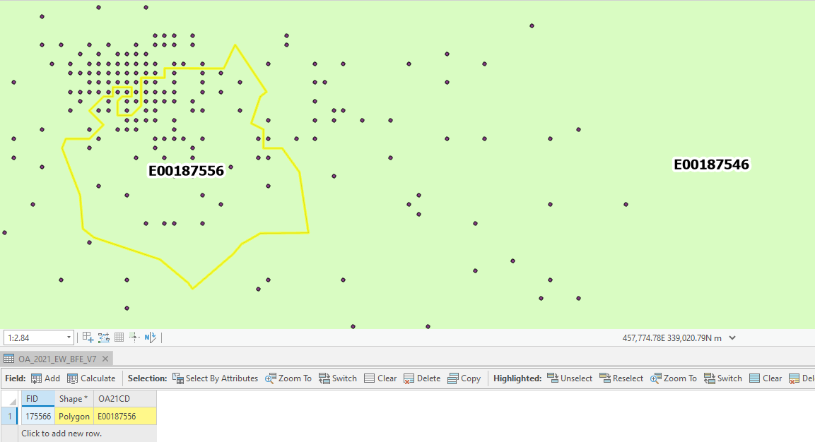

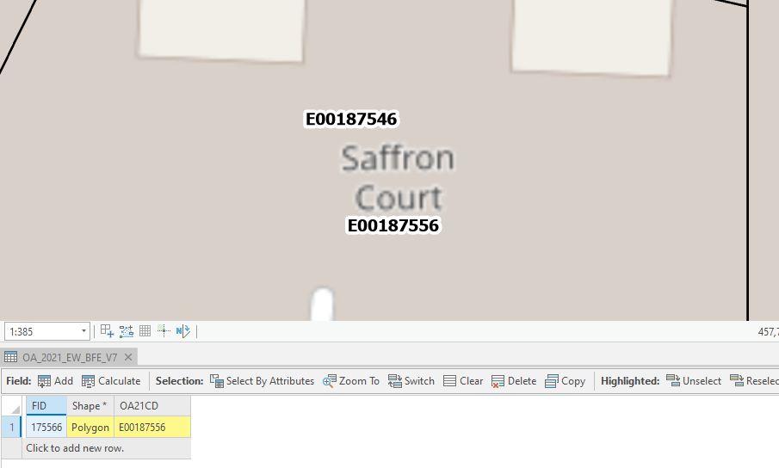

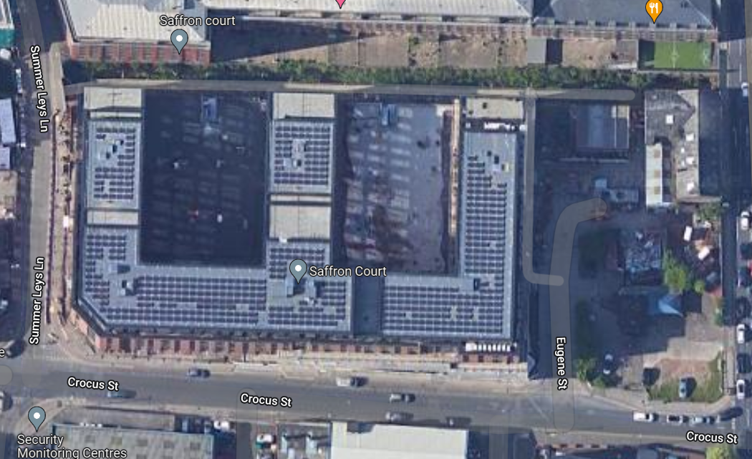

Data Tolerance, Accuracy and Currency

Tolerance
SAM measurements are calculated and stored as hectares to 4 decimal places (i.e. at 1 metre level) and released as hectares to 2 decimal places (i.e. 100 sq metres) as a standard for publication. For the KM2 it is stored to 4 decimal places and published to 4 decimal places as well. Especially for the Output Areas.

Accuracy: Measurements for Great Britain
The inherent deficiencies in precision within Boundary-Line™ compared to the real world may produce ‘ground measurement’ area variations of approximately +/- 1 sq kilometre. The reasons for some of these area variations are:
- Boundaries are fixed to features as captured during the surveying process, but such features can change shape or course over time (e.g. Morecambe Bay).
- much of the Mean High-Water feature has been heavily generalised in the Boundary-Line™ product to avoid excess data volume levels adversely impacting on the product’s functionality; and
- Boundary-Line™ has been created from Ordnance Survey’s 1:10,000 scale mapping which is a generalised product; this can mean that some digital boundaries have been ‘attached’ to ground features that are already redrawn or generalised or may be off-set, such as streams, hedges etc.

The use of Ordnance Survey's MasterMap® topographic layer hydrology theme means that measurements for tracts of inland water have been captured to a different set of specifications and standards which produce measurements that are more accurate than those derived from Boundary-Line™. Further information on Ordnance Survey's MasterMap® specifications can be found at https://www.ordnancesurvey.co.uk/business-government/products/mastermap-topography

Comparisons with Previous Area Measurements
Inevitably, area measurements will differ in some instances from those made available previously. Some differences will be due to boundary changes or improvements to the source data, or for other reasons such as foreshore changes. Also, previous measurements are likely to have been produced to different levels of accuracy and consistency for various purposes using a range of methodologies.
Extensive quality checks have been completed and a comparison of the previously published local authority area measurements has been made. Any enquiries will be investigated, on request, by ONS Geography. Please contact ons.geography@ons.gov.uk.
Where SAM measurements for electoral and administrative areas are being used and there are differences with area measurements made available previously the following explanatory footnote should be provided:

“The area measurements are a definitive set derived from boundaries maintained by Ordnance Survey and Ordnance Survey of Northern Ireland. The current measurements may differ from those published previously in tables, publications, or other statistical outputs, even allowing for boundary changes or changes to the physical structure of the land because of improvements to the source of the data.”

Currency of the Area Measurements
These are the SAM measurements for the 2021 Statistical Geographies – Output Areas, Lower layer Super Output Areas, Middle layer Super Output Areas and all those geographies above including Lower-Tier Local Authorities, Upper-Tier Local Authorities, Regions (including Wales), countries and national.

Guidance on the Use of Measurements for Statistical Purposes
The choice of area measurements to be used in a situation will depend on the data being presented, and a definition of the chosen measurements should be included in the relevant publication or dataset.

Compiling Population Density Measurements
The recommended approach is to use the ‘Land Area’ measurement (Area to Mean High Water Excluding Area of Inland Water) to compile population density measurements.

Other Uses of Measurements
The choice of area measurements to be used will depend on the data being presented. However, as general guidance, it is suggested that:
- If a measurement is required to describe the extent of an administrative area then the ‘Total Extent’ measurements should be used for contextual purposes; but note that the ‘Area to Mean High Water’ measurements should be used for areas in Northern Ireland because there are no separate ‘Total Extent’ measurements;
- If a measurement is required for calculating population density figures the 'Land Area' (Area to Mean High Water Excluding Inland Water) measurements should be used.
- If a measurement is required to describe the extent of the land mass (i.e. in a ‘land use’ context) then the ‘Area to Mean High Water’ measurements should be used.

Specific Measurements
Some area measurements will appear to be excessive compared with expectations. The reasons are varied and can include instances where the 'Extent of the Realm' measurement includes bounding sea areas and bays, islands, and piers. Area to Mean High Water measurements can also include tracts of rivers and towpaths.

Conditions of Use
ONS will not be liable to the user or any other party for any loss, damage, inconvenience, or expense resulting from the use of, or reliance upon, the standard area measurements (SAM).
Under the terms of the Open Government Licence (OGL) and UK Government Licensing Framework, anyone wishing to use or re-use ONS material, whether commercially or privately, may do so freely without a specific application for a licence, subject to the conditions of the OGL and the Framework. Users reproducing ONS content must include a source accreditation to ONS. The text for this can be found on our Licences page on the ONS website - https://www.ons.gov.uk/methodology/geography/licences
ONS standard area measurements data may be used as follows:
- Copied, distributed, and transmitted.
- Adapted.
- Exploited commercially whether by sub-licensing, combining it with other data or by including it in your own products or applications.
- Disseminated within National Statistics without charge or royalty fee to Ordnance Survey. Reproduced in datasets produced by National Statistics for external use. Any copied or manipulated measurement tables, or measurements provided in statistical outputs, must contain the following acknowledgement:
“Area measurements have been created by the Office for National Statistics. Crown Copyright. All rights reserved [date].”
You must include the same acknowledgment requirement in any sub-licences that you grant and a requirement that any further sub-licensees do the same.

